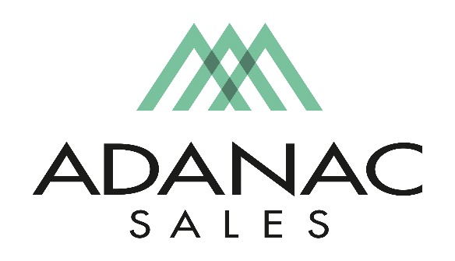

Distribution Sales Representative – Lower Mainland

Adanac Sales is an Independent Manufactures Representative covering the British Columbia Market.

We are currently seeking to fill an open Resident Outside Sales position for the Lower Mainland territory. If you’re looking for a fast pace exciting and rewarding opportunity and are an energetic, positive minded person with a Minimum 2 years of Professional Sales Experience, we would like to meet with you. Knowledge in the Electrical Industry is beneficial

Adanac Sales takes pride in attracting and retaining the best people in the electrical industry. To do so we focus strongly on employee development, commit to high ethical standards and promote an organizational culture of teamwork with a respectful work environment. We offer a competitive compensation package as well as comprehensive extended health & dental plan and other benefits in addition to ongoing training opportunities.

Job Description:

The Distribution Sales Representative primary responsibilities include marketing new products, launching promotions & sales programs along with providing product training, hosting counter day events, merchandising and inventory support with our distributor partners. Contractor and end-user calls are also required.
Time management skills and the ability to work in both a team environment and individually are crucial to your success along with skills required to effectively communicate product training sessions and seminars.

The successful candidate should possess the following skills.

- Presentation skills, confidence in delivering a message along with a ‘Hunter” mentality are key to success in this position.
- Team Oriented
- English language proficiency
- Effective time management skills
- Well organized
- Be a self-starter with the ability to take initiative when needed

This position may require periodic travel to the USA for Factory Product Training. A valid passport and driver’s license are required. A late model vehicle is required for this position. All tools such as laptop, cell phone etc are supplied in addition to mileage plan for business use of vehicle, expense account for business related expenses are also included.

If you believe your skill set matches the above description and are an enthusiastic, innovative, passionate and an energetic individual we would like to hear from you! Adanac provides a challenging work environment with growth opportunities. Interested applicants should forward their resume to admin@adanacsales.com

We thank all interested applicants however please note that only those chosen for an interview will be contacted.

