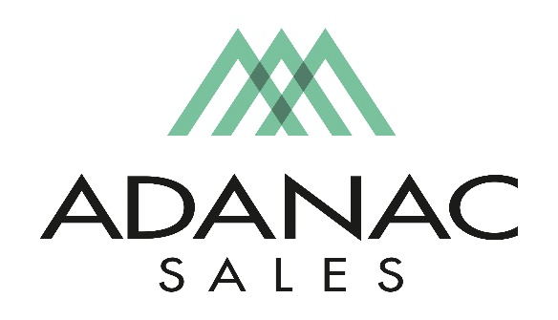

Industrial Sales Representative

Adanac Sales is an Independent Manufactures Representative covering the British Columbia Market.

We are currently seeking to fill an open Resident Outside Sales position for Vancouver Island. If you’re looking for a fast pace exciting and rewarding opportunity and are an energetic, positive minded person with a Minimum 2 years of Professional Sales Experience, we would like to meet with you. Knowledge in the Electrical Industry is beneficial

Adanac Sales takes pride in attracting and retaining the best people in the electrical industry. To do so we focus strongly on employee development, commit to high ethical standards and promote an organizational culture of teamwork with a respectful work environment. We offer a competitive compensation package as well as comprehensive extended health & dental plan and other benefits in addition to ongoing training opportunities.

Job Description:
In this position, the Industrial Sales person will work closely with the manufacturer partners we represent specifying product with consulting engineers and end-users for industrial projects in BC. Additionally, supporting our distribution partners with product training, sales support and making joint sales calls on end-users and contractors. The ability to provide product presentations and assisting with product application utilizing your technical capabilities will also be key to the success of this position.
The successful candidate should possess the following skills.
- Strong B2B sales background
- Intermediate computer skills (MS Office) with the ability to learn new software
- English language proficiency
- An ability to work under time-sensitive project deadlines. (Effective time management skills)
- Is a self-starter with the ability to take initiative
- Effective public speaking and presentation skills
- Ability to close projects
This position requires travel in BC in addition to periodical travel to the USA for Factory Product Training so both a valid passport and driver’s license is required.
If you believe your skill set matches the above description and are an enthusiastic, innovative, passionate and an energetic individual we would like to hear from you! Adanac provides a challenging work environment with growth opportunities. Interested applicants should forward their resume to admin@adanacsales.com.

