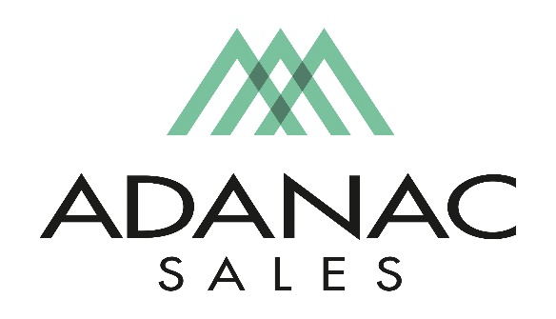
Residential Specification Sales
Adanac Sales is an Independent Manufactures Representative covering the British Columbia Market.
We are currently seeking to fill an open Residential Specification Sales position for our office in Port Coquitlam. If you’re looking for a fast pace exciting and rewarding opportunity, are energetic, positive minded and are comfortable calling on Interior Designers, Architects, Builders and Engineers, dealers and contractors, we would be interested in meeting with you.
Adanac Sales takes pride in attracting and retaining the best people in the electrical industry. To do so we focus strongly on employee development, commit to high ethical standards and promote an organizational culture of teamwork with a respectful work environment. We offer a competitive compensation package as well as comprehensive extended health & dental plan and other benefits in addition to ongoing training opportunities.
Job Description:
The Residential Specification Sales position is primarily responsible for building positive long-term relationships with Interior Designers, Architects, Residential Builders, Electrical Engineers along with our Dealer channel that is focused on the Luxury Residential Market. The successful candidate should be comfortable with providing presentations on products such as Automated Window Coverings, High End Lighting, Lighting Control Systems, Custom In-floor Heating and many other residential products. Ongoing product training is key to the success of this position.
The successful candidate should possess the following skills.
· Strong B2B sales background
· English language proficiency
· Effective time management skills
· Is a self-starter with the ability to take initiative
· Effective public speaking and presentation skills
· Ability to close projects
· Detail Oriented
This position may require periodic travel outside of the Lower Mainland in addition to periodical travel to the USA for Factory Product Training so both a valid passport and driver’s license is required.
If you believe your skill set matches the above description and are an enthusiastic, innovative, passionate and energetic individual we would like to hear from you! Adanac provides a challenging work environment with growth opportunities.
We thank all interested applicants however please note that only those chosen for an interview will be contacted. Interested applicants should forward their resume to admin@adanacsales.com

