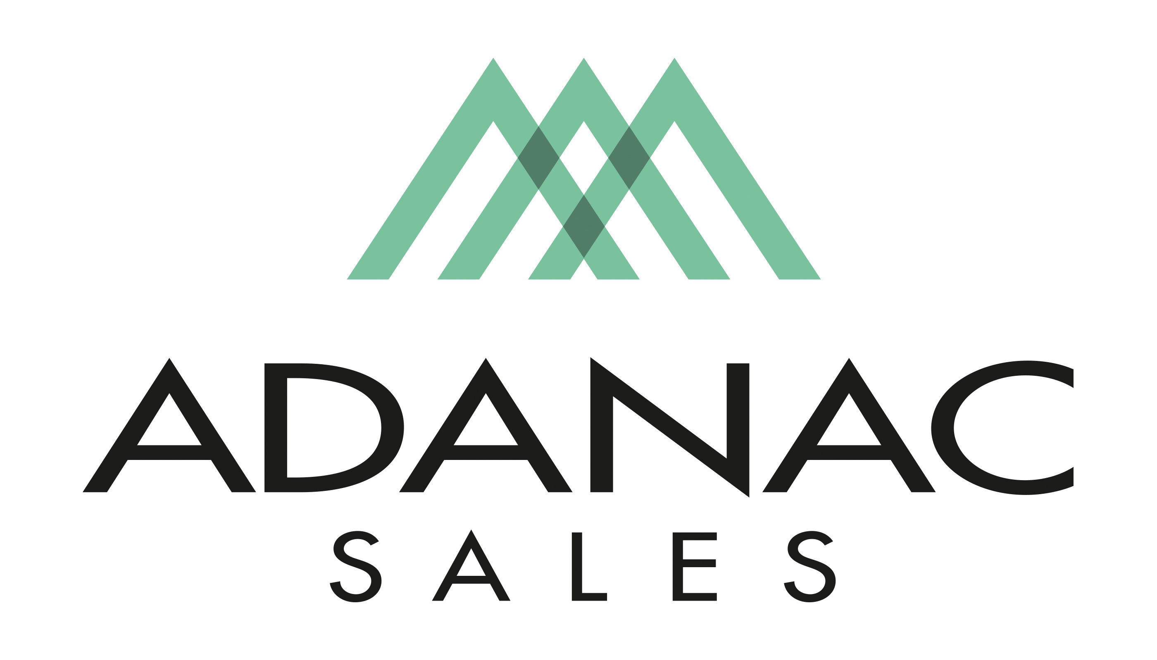

Order Entry, Customer Service Representative

Adanac Sales is an Independent Manufactures Representative covering the British Columbia Market.

Due to expansion, we are currently seeking to add an Order Entry, Customer Service position for our office in Port Coquitlam. If you are looking for a fast paced, exciting and rewarding opportunity, we would be interested in meeting with you.

Adanac Sales takes pride in attracting and retaining the best people in the electrical industry. To do so we focus strongly on employee development, commit to high ethical standards, and promote an organizational culture of teamwork with a respectful work environment. We offer a competitive compensation package as well as comprehensive extended health & dental plan and other benefits in addition to ongoing training opportunities.

Job Description:

The Order Entry, Customer Service position is responsible for building positive relationships with customers through accurate entry of sales orders across our line card. This position would also require the follow up of price checks, expediting of orders and other related activities. The successful candidate is also required to work closely with our Inside Sales Team, Outside Sales Team and Projects Department in a supportive and collaborative way and may be required to travel to customer or supplier locations for training purposes. This position reports to the Sales Manager.

The successful candidate should possess the following skills.

- Intermediate computer skills (MS Office) with the ability to learn new software
- Basic mathematical skills
- English language proficiency
- An ability to work under time-sensitive project deadlines. (Effective time management skills)
- An ability to adjust to heavy periods of workload when required
- An ability to maintain focus while working in an environment of frequent interruptions
- A positive and friendly phone manner
- Is a self-starter with the ability to take initiative

If you believe your skill set matches the above description and are an enthusiastic, innovative, passionate and an energetic individual we would like to hear from you! Adanac provides a challenging work environment with growth opportunities. Interested applicants should forward their resume to admin@adanacsales.com

We thank all interested applicants however please note that only those chosen for an interview will be contacted.

