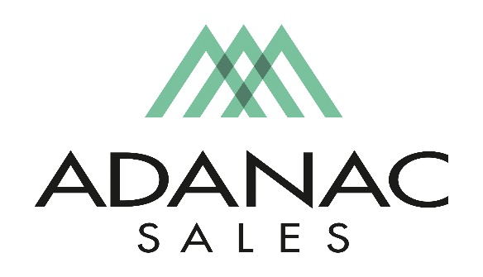
Lighting Specialist – Outside Sales
Adanac Sales is an Independent Manufactures Representative covering the British Columbia Market.
Due to expansion, we are currently seeking to fill an open Lighting Specialist – Outside Sales position. If you are looking for a fast pace exciting and rewarding opportunity, we would be interested in meeting with you.
Adanac Sales takes pride in attracting and retaining the best people in the electrical industry. To do so we focus strongly on employee development, commit to high ethical standards, and promote an organizational culture of teamwork with a respectful work environment. We offer a competitive compensation package as well as comprehensive extended health & dental plan and other benefits in addition to ongoing training opportunities.
Job Description:
Supported by an internal team of Project Quotation and Inside Sales staff, the Lighting Specialist would be responsible for working closely with our distribution partners focusing on daily sales support, project quotation support, JSC’s and inventory management. The successful candidate is also tasked with working closely with the Specification Community, Electrical Contractors and the Lighting Design community to ensure the manufacturers represented by the Company are being specified where possible on any Commercial, Residential and Industrial projects.
The successful candidate will possess the following skills.
· Minimum 2 years lighting experience
· Ability to read electrical drawings
· Interact with industry professionals and develop a network of clients & contacts.
· An ability to work under time-sensitive project deadlines. (Effective time management skills)
· Proven experience working with commercial/residential business partners.
· Effective problem resolution and decision-making skills.
· Ability to work well in both independent and team settings.
· Excellent verbal and written communication skills.
This position may require periodic travel to the USA for Factory Product Training. A valid passport and driver’s license are required. A late model vehicle is required for this position. All tools such as laptop, cell phone etc are supplied in addition to mileage plan for business use of vehicle, expense account for business related expenses is also included.
Salary range for this position is $60,000-$85,000 a year.
We thank all interested applicants however please note that only those chosen for an interview will be contacted Interested applicants should forward their resume to admin@adanacsales.com

